Meta Title:
Shop Top Notch Floor Coverings in Houston
Meta Description:
We offer the finest floor coverings at Houston Custom Carpets. Shop now for premium quality and personalized coverings for the floor to spruce up your space.
https://houstoncustomcarpets.com/products/floor-coverings/ | Floor Coverings | 1.3k
 | Wood Flooring houston | 260
 | Best Carpet | 2.4k
 | stick & peel floor tiles | 2.4k
 | floor tiles | 22.2k
 | waterproof laminate flooring | 9.9k
 | Hardwood flooring | 49.5k

Get Floor Coverings for Every Style

Houston Custom Carpets is your one-stop solution for all your floor covering needs in Houston. With us, you will not be disappointed, whether you prefer a minimalist style or the traditional Gothic style for your floor. Regardless of the space or your monetary status, we ensure all your floor dreams become a reality. Feel free to discuss your flooring project to turn your interiors into beautiful floors with our perfect fit. We have the best designs for your commercial and residential spaces and we can install all the necessary materials for you.

Need Help Choosing the Perfect Floor?

Upgrade Your Flooring Experience with Houston Custom Carpets:

Houston Custom Carpets offers floor covering services because we comprehend that the best floor product can definitely change the look of every space in a home. Select from a broad variety; carpets, hardwood, vinyl, tiles, and laminates are available to fit your fancy, need, and desire.

Installation | Underlayment | Surface Preparation | Inspection
Our experienced installers pay attention to detail and fit and finish of the floor installations, so when you get your floor covering, it is ready for use. | We offer professional services for the underlayment of floor structures with the aim of offering protection and insulation thus enhancing durability of floor coverings. | The detailed surface preparation work our experts undertake ensures that there is a completely flawless surface when your new floor covering is being laid down. | After the completion of work, our experts held a final inspection to guarantee that your floor covering was properly installed and looks like it is supposed to.

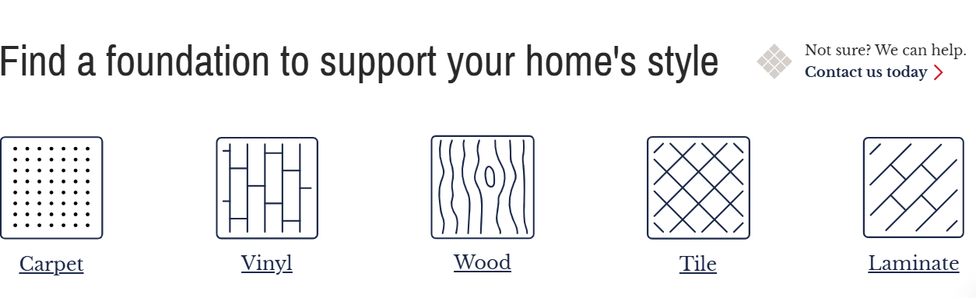

Find a Perfect Foundation to Support Your Floor Style:

If you are looking for the ideal floor covering for your home, come to Houston Custom Carpets. Our diverse range of options includes:

Carpet Flooring | Vinyl | Hardwood Flooring
Our luxurious carpets will not only make your house look stunning but will also bring comfort to your feet. Whether it is a conventional design or a contemporary design, you will always get the best carpets. | Make your home sophisticated with our Vinyl Flooring luxury collections. High-quality and tough, our vinyl flooring is suitable for any area with heavy traffic or less traffic and looks great from every angle. | Select from a huge list of premium quality fine hardwood floors to give warmth and elegance to your home. Our wood floors are not just good for the feet and other body parts, but they are value additions as well.

Tile Flooring | Laminate Flooring
Upgrade your environment with our superior-quality floor tiles. Our vast range of tiles from stick & peel floor tiles to ceramic and porcelain to glass and natural stone looks, add an element of luxury to modern interiors. | Discover the elegant look of real hardwood and the application of waterproof laminate flooring at its best. Our laminates are tough and durable for day-to-day use in any home, making them an intelligent investment.


How Does Our Process of Floor Coverings Work?

At Houston Custom Carpets, the challenge that our clients face when selecting a floor covering for their homes is well understood. That is why we ensure it is easy and fun for our customers to attain this goal. Here's how it works:

Step 1 | Click the button below to book your consultation. We will visit your home, measure your rooms, and help you envision what your new space will look like.
Step 2 | Browse through our large floor display of different carpet designs and styles. Our team will effectively assist you get the right floor covering for your home.
Step 3 | Once you’ve made the selection of the design, style, and product, we will give you an exact cost breakdown of the project in terms of installation and duration.
Step 4 | Our highly experienced installation team shall then professionally lay down your chosen new floor covering and help give your area that new stunning look you desire.

Book Your Consultation Today!

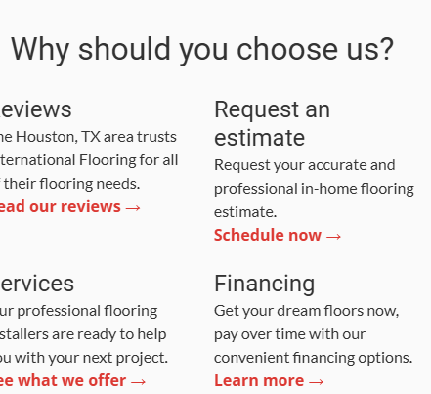

Why Choose Houston Custom Carpets for Your Flooring Needs?

Choose Houston Custom Carpets to get the finest wood flooring in Houston. Here are a few reasons why we stand out from the competition:

Professional Expertise | Quality Materials | Installation Excellence
With a qualified and resourceful team of flooring specialists, Houston Custom Carpets aims to go the extra milestone to guarantee customer satisfaction on every level. | The flooring materials we employ are of excellent quality and sourced from reliable manufacturers so as to give your new floor covering the maximum possible working life. | Our professional technicians will install the floors professionally by following all the laid standards in the market to make sure that you get the best out of your floors.

Let’s Turn Floor dreams into reality with Houston Custom Carpets!

Welcome to Houston Custom Carpets where our vision is to give you the best flooring services in terms of style that you desire. Whether you have a narrow kitchen or a large living room, we offer numerous choices and convenient conditions to invite comfort in your homes with excellent floor solutions. Stop searching for the ideal floor contractors and choose Houston Custom Carpets today and be sure to get the best floor covering in Houston.

FAQ’

Does hardwood flooring increase the value of the home?

Yes, a hardwood floor is one of the best investments that one can make that will result in a higher value of your home. For potential buyers, it adds a specific charm to the house.

Is installing hardwood floors easy to accomplish?

Hardwood flooring can actually be installed by an individual but it demands precision, skill, and tools. For the most part, homeowners should seek the help of a contractor so that installation turns out to be perfect.

Is the hardness level the same for every hardwood material?

Not all hardwoods are created equal; they are of different degrees of durabilities. Some, such as oak and maple, are more robust than others, such as walnut and cherry, which can easily be scratched and dented.

How long does hardwood flooring last?

If properly maintained, some types of hardwood floors can last a lifetime or can still be as good as new for generations. In general, hardwood floors last for many years before requiring replacement which also adds elegance and worth to your house.

What is the proper way to clean up spills on hard wooden floors?

In the event of a spill, clean up the liquid using a clean, dry cloth as soon as possible. In this case, wash gently with a slightly damp cloth, and mild washing soap. Do not use water or strong chemicals a lot on your hardwood floor because it will wear out quickly.

